TITLE: TIMES NEW ROMAN 14 BOLD (40 WORDS MAXIMUM)

First name Family name¹, First name Family name^{2*}, and First name Family name³

¹: Affiliation, City and Country; email: bei_institute@outlook.com
²: Affiliation, City and Country; email: bei_institute@outlook.com
³: Affiliation, City and Country; email: bei_institute@outlook.com

*: corresponding author

Keywords: keyword 1; keyword 2; keyword 3; keyword 4; keyword 5

Abstract: 400 words maximum

1. Introduction
The official language of the conference is English. The maximum length of a manuscript is four pages, including all figures and tables, in Letter format (8.5 in. by 11.0 in. or 215.9 mm by 279.4 mm). The margin of the manuscript is 1 in. (25.4 mm) on all sides. Times New Roman at a font size of 12 is used. Add one line spacing between sections.

2. References
The format of reference is in Harvard style (last name, date). All reference must be referenced (Bei, 2023; Bei and Ieb, 2023; Bei et al. 2023) and a list of the references is placed at the end of the manuscript in alphabetical order.

Bei. 2023. Bridge engineering institute conference, Journal of Bridge Engineering Institute, 1(1), 25-35.

Bei, A.B. and Ieb, C.D. 2023. Bridge engineering institute conference, Journal of Bridge Engineering Institute, 1(2), 36-45.

Bei, A.B., Ieb, C.D., and ACI, E.F. 2023. Bridge engineering institute conference, Journal of Bridge Engineering Institute, 1(3), 46-50.

2.1. Mathematical equations
Equations are numbered, as shown in Eq. 1.

$\text{FI}=\left(\frac{E_{r}^{\text{control}}+E_{r}^{\text{CFRP}}}{E_{s}}−1\right)=\frac{Π}{E_{s}}$ (1)

2.2. Figures
All figures must be mentioned in the main text. SI units are encouraged.

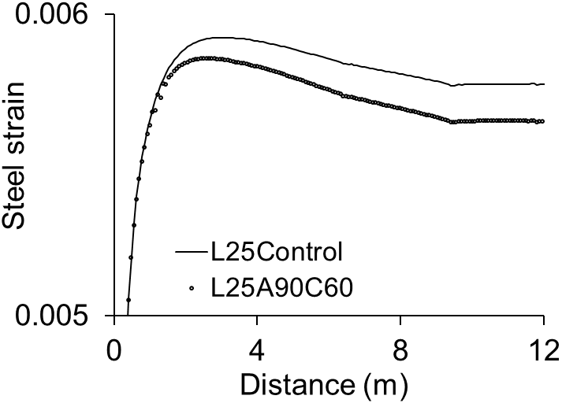
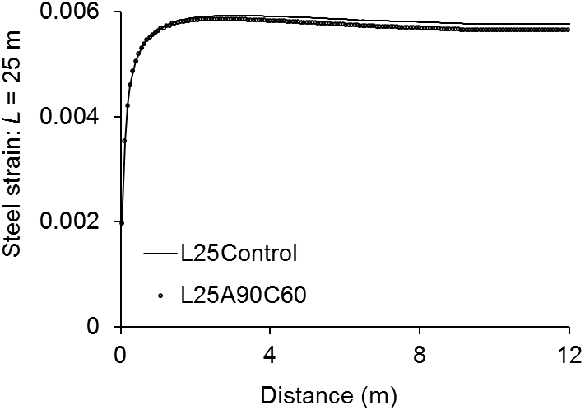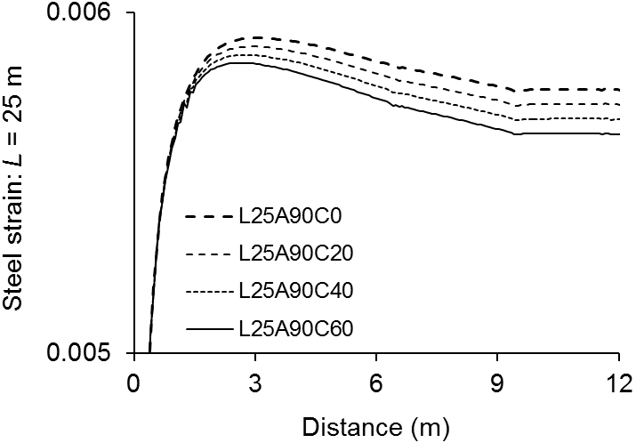
(a) (b)
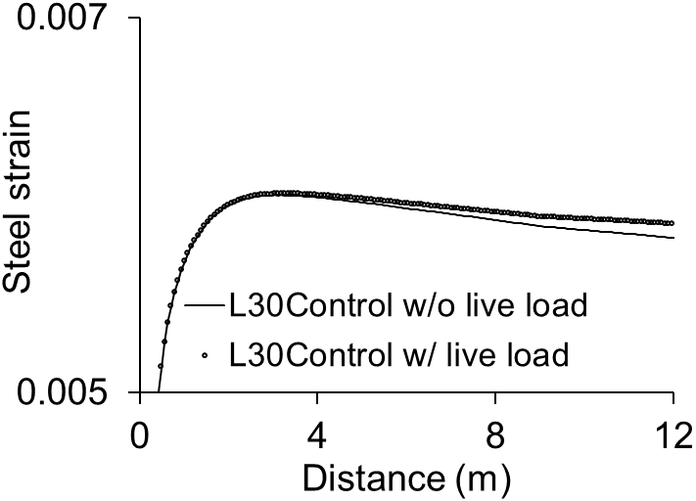
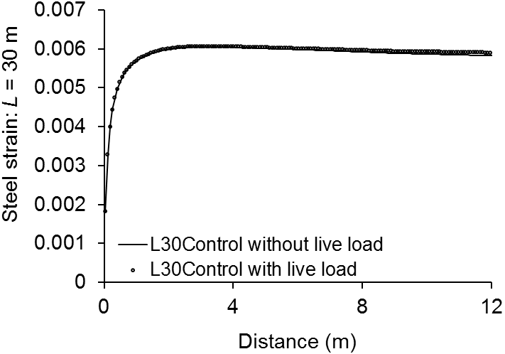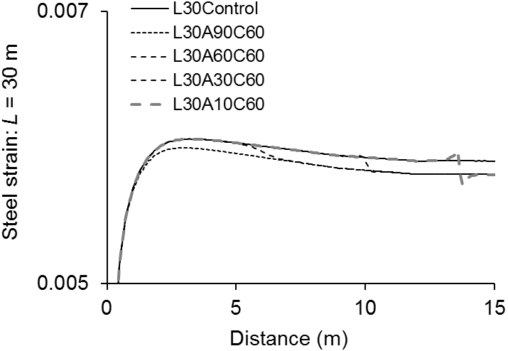
L30Control
L30A90C60
L30A60C60
L30A30C60
L30A10C60
(c) (d)

Fig. 1. Behavior of prestressing steel in strengthened girders subject to live load: (a) effect of CFRP-strengthening; (b) effect of post-tensioning level; (c) effect of live load; (d) effect of strengthening coefficient α

2.3 Tables
Tables must be mentioned in the main text.

Table 1. Girder details
 | Length (m) | Depth (mm) | Widthª (mm) | Number of bundled strands | A_{p}  (mm²) | Prestressing level^{b} (%)
Girder A | 25 | 1750 | 600 | 3 | 3560 | 64
Girder B | 30 | 2000 | 660 | 4 | 4750 | 65
Girder C | 35 | 2200 | 720 | 5 | 5940 | 68
ª: width of bottom flange
^{b}: prestressing level against ultimate strength
A_{p}= cross-sectional area of prestressing steel strands

